**Intro to Git/GitHub**

Why???

1. It’s a version control system. That is the single most important reason for its existence. If the history of what you are working on matters, you need a GitHub account.
2. It’s a popular and neat way to disseminate your work. Github creates a repository (collection) of files which can be accessed by anyone. You can make a (static) webpage. You can add an introduction and explanation. It can include many type of code. You can update your repository.
3. It’s great for collaboration in teams. So if you are a part of a team working on a project and you want to work on parts of it together without stepping on each other’s toes, you need GitHub. It’s a more sophisticated DropBox (or Box). You can work locally and then “push” the updates to the remote repository. It keeps track of your work history and you can go back to previous versions. Once you “commit” the changes to the remote repository, others can see it too and work on the changes you have done. The repository has a “tree” like structure so people can work on parts of the project without affecting what others do in other parts.

BUT… you don’t have to be part of a team, you can be a ream of one and use Github to distribute your work to the world. Github will host it for you! It’s easy to use.

Finally, Git is the version control software developed by Linus Torvalds who invented Linux. Github is the web service version. That’s a simplified distinction and for the most part all you need is Github.

**Opening an account**

Go to <https://github.com> and press sign up (or sign in if you already have an account).



You need to pick a username and e-mail and password.

Congratulations!

The front page offers a nice guide to everything that Github offers. So you can leave this guide now and go there if you want.

**Configuration**

There is not a lot to do. You can access your account settings and stats from the upper right corner.

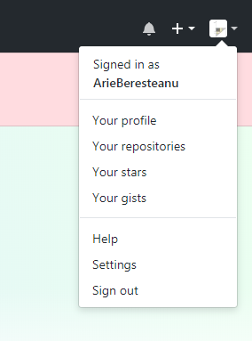

You can add a picture, if you want. Etc.

**Creating a repository**

On the front page there is a (green) button ‘New repository’. Click on it and you’ll see this:

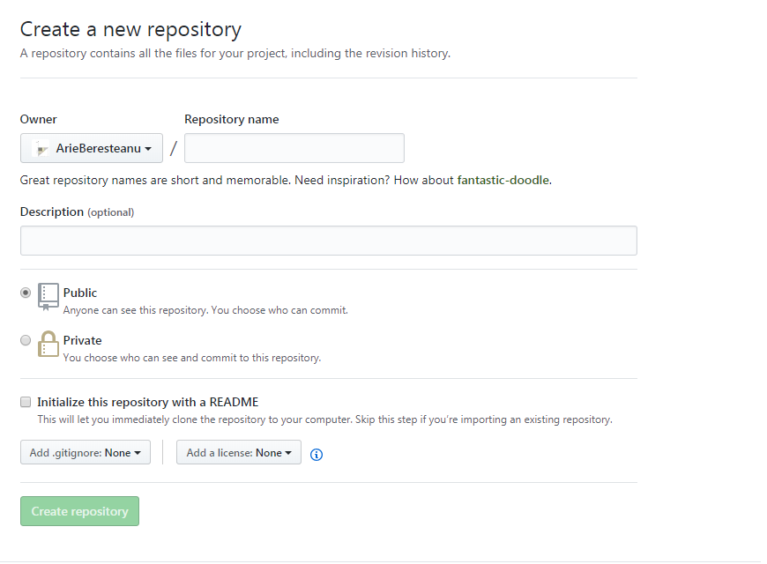

4

3

2

1

It asks you to choose a name for the repository.

If you are not a paying customer, you’ll have to keep it public.

Check the box asking to “Initialize this repository with a README”. That’s a good thing to do.

We can ignore the other buttons and click the (green) button saying create repository.

It looks like this:

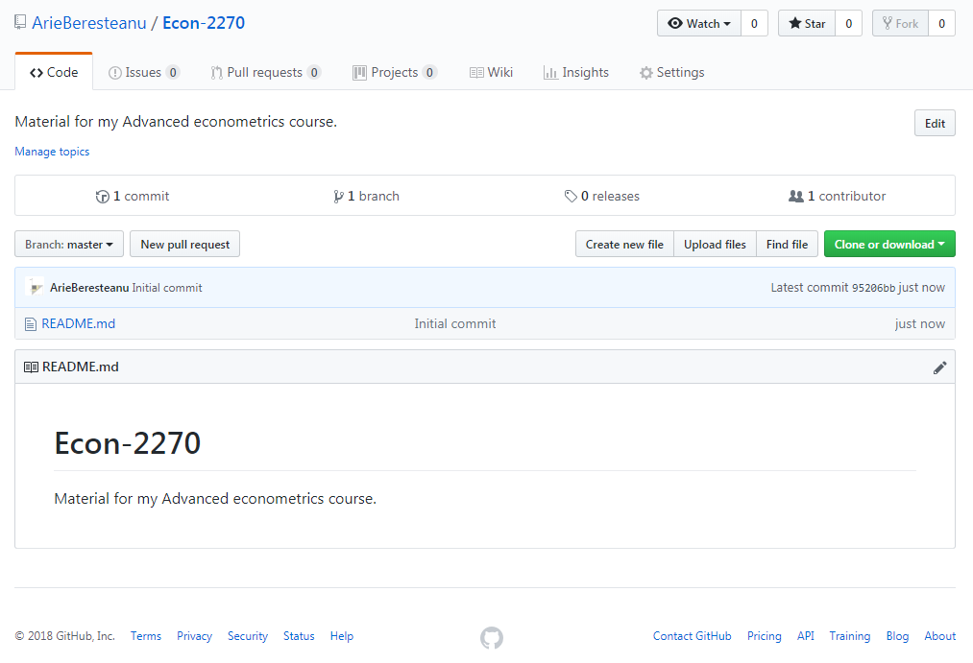

You just created a repository. If you want to sound cool, you call it a repo.

You can see it has one contributor (you) and one branch (the main one) and only one commit (the README file). There are also no issues or pull requests and so on. It’s a brand new repo.